Control Award Content Sheet

|  |  |
| --- | --- |
| Team # 7155 | Team Name: The Quantum Potentials |

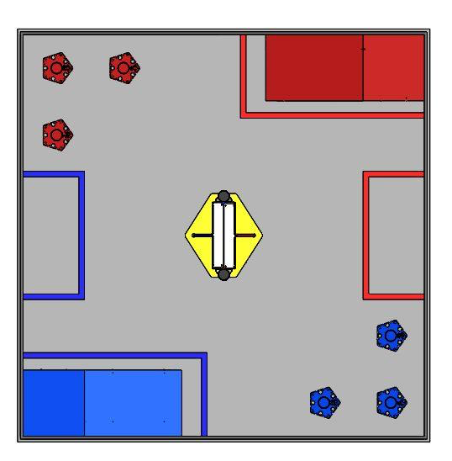

Autonomous:

Driver Controlled: